
Independent Monitoring & Verification Proposal
  - Third-Party Inspection of Drain Desilting and Cleaning Works Carried Out by Vendors across Delhi (Approx. 2000 km)
Two-round verification to ensure readiness before monsoon
Prepared for Government of NCT of Delhi (PWD)
Prepared by Quality Council of India (QCI)

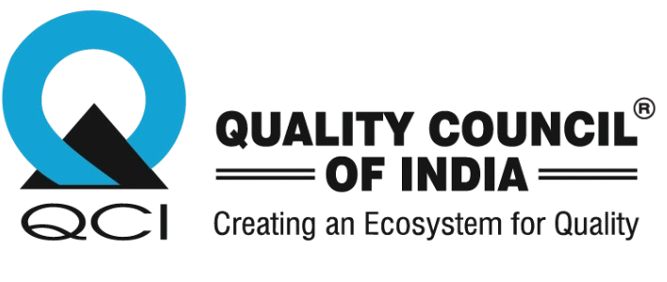

Contents
Executive Summary 3
1. About Quality Council of India (QCI) 3
The Department of Promotion of Industry and Internal Trade (DPIIT), Ministry of Commerce and Industry is the nodal point for all matters related with QCI. The Chairman of QCI is appointed by the Hon’ble Prime Minister of India. 4
Other past experiences of QCI GFC and ODF Protocols- MoHUA 5
2. Background and Need 6
3. Project Understanding and Objectives 7
4. Scope of Work 7
5. Methodology and Approach 9
6. Deliverables and Reporting 12
Illustration: Monitoring dashboard (sample view) 13
7. Governance and Communication 14
8. Timeline 14
9. Team and Deployment Plan 15
10. Financial Proposal 16
11. Assumptions, Dependencies and Risk Management 18
12. Annexures (Templates) 19

Executive Summary
Government of NCT of Delhi has engaged multiple contractors for desilting/cleaning of storm water drains across Delhi. With the monsoon approaching, it is critical to ensure that drains are cleaned as per the awarded scope of work and are maintained in running condition to avoid water-logging and flooding.
Quality Council of India (QCI) proposes an independent, two-round verification programme covering all divisions and all contractors. Phase 1 will establish the baseline and identify drains that are not cleaned, partially cleaned or clogged. Phase 2 will re-verify the failed locations and certify readiness before 15 May.
 |  |  | 
Network length  ≈ 2000 km | Contractors  ≈ 36 | Deadline  15 May | Verification rounds  2

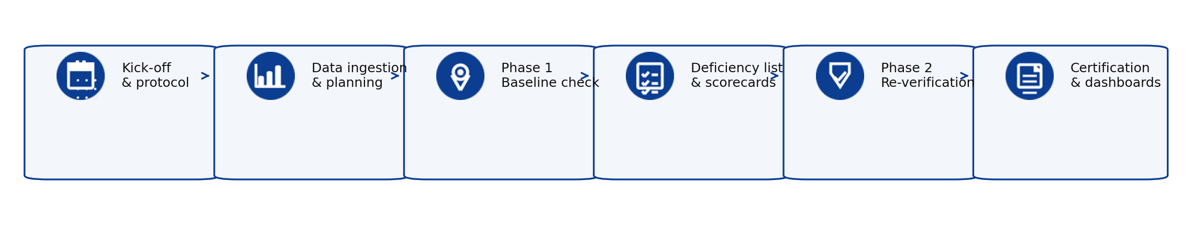
Key deliverables:
- Division-wise and contractor-wise deficiency list after Phase 1
- Geo-tagged evidence-based scorecards and dashboards
- Re-verification results of failed/uncleaned drains (Phase 2)
- Certification note confirming drains are cleaned before 15 May (as verified)

1. About Quality Council of India (QCI)

The Quality Council of India (QCI) has been set up as a non-profit autonomous society registered under Societies Registration Act XXI of 1860 to establish an accreditation structure in the country and to spread quality movement in India by undertaking a National Quality Campaign.
It was established as the National body for Accreditation through initial funding by the Government of India only with the Indian Industry represented by the three premier industry associations,
- Associated Chambers of Commerce and Industry of India (ASSOCHAM),
- Confederation of Indian Industry (CII) and
- Federation of Indian Chambers of Commerce and Industry (FICCI).

The Department of Promotion of Industry and Internal Trade (DPIIT), Ministry of Commerce and Industry is the nodal point for all matters related to QCI. The Chairman of QCI is appointed by the Hon’ble Prime Minister of India.
The Council was established to create a mechanism for third party assessment of products services and processes. In line with the best international practices, it was envisaged that the Council will play the role of the National Accreditation Body (NAB) as per existing eco-system of quality around the world and will ensure that the quality of life of citizens around the world is improved. It was therefore befitting that the Council was organized as an independent organization from both government and Industry and functions as an Independent Professional body with its own rules, powers and functions strictly as per the MoHUA of the society. QCI has a pool of resources to conduct the third-party verification exercise.
- We have signed a MoU with Indian Statistical Institute (ISI) to provide guidance on analysing, interpreting and presentation of statistically relevant data.
- We have on-board consultants with specialization of ground water management and drains.
- Our senior directors and directors are technically qualified to lead the project with over 20 years of experience.
- The Project Managers from our young professional program, constituting Project Planning and Implementation Division (PPID), are well versed with project.

Governing Council
(39 Member Body)
Governing Body
(21 Member Body)
Secretariat
Secretary-General
SPECIAL PROJECTS GROUP
PPID
PADD
ZED
Project Planning and Implementation Division
Project Analysis and Documentation Division
Zero Defect and Zero Effect Division
NBQP
National Board for Quality Promotion
NABCB (10,000+ auditors/inspectors of CABs) National Accreditation Board for Certification Bodies
NABH (1300+ assessors)
National Accreditation Board for Hospitals and Healthcare Providers
NABET (600+ assessors)
National Accreditation Board for Education and Training
NABL (2500+ assessors)
National Accreditation Board for Testing and Calibration Laboratories

For this assignment, QCI will act as an independent verification agency to provide objective, evidence-based assessment of drain cleaning work carried out by the contractors.

Past experiences of QCI
GFC and ODF Protocols- MoHUA 2023-26
QCI conducted the Open Defecation Free and Garbage-Free City assessment in over 4,500+ and3,500+ Urban Local Bodies (ULBs) respectively. The assessment evaluated the solid waste management practices of the ULBs and assigned star ratings accordingly. Field assessors conducted on-ground inspections of STPs, FSTPs, storm water drains, and nullahs to verify cleanliness, functionality, availability of screens/filters, absence of floating waste, and maintenance schedules. Processing facilities and sanitation assets were physically verified through geo-tagged photographs and direct observation.
Jal Hi Amrit 2024-25
QCI executed a large-scale third-party inspection of 860 STPs to ensure compliance with AMRUT scheme guidelines. The evaluation methodology integrated a ten-parameter scoring matrix with on-site sample collection and subsequent testing at NABL-accredited labs. Results were utilized to categorize plants into "STAR" ratings, facilitating a merit-based incentive distribution process.
Swachh Survekshan 2021 - Ministry of Housing & Urban Affairs
Data was captured using survey instruments and a portal developed in consultation with MoHUA, with real-time tracking of submissions. Inputs from Service Level Progress, Direct Observation, and Citizen’s Voice were uploaded and validated through the portal. Field assessors conducted on-ground inspections of STPs, FSTPs, storm water drains, and nullahs to verify cleanliness, functionality, availability of screens/filters, absence of floating waste, and maintenance schedules. Processing facilities and sanitation assets were physically verified through geo-tagged photographs and direct observation. Deviations between portal claims and field findings were factored into scoring as per the validation matrix.
Swachh Survekshan (Urban) 2017 - Ministry of Housing and Urban Affairs
City Ranking Under Swachh Survekshan (Urban) 2017 surveyed the existing sanitation and solid waste management conditions in the city. A list of indicators pertaining to the practice of sweeping, collection, transportation, processing and disposal of solid waste, and access to sanitation were surveyed. The survey includes collection of primary information, field and side visits to conduct interviews along with photo documentation of field conditions.
SBM (ODF, ODF+, ODF++) – (2016-2021) - Ministry of Housing and Urban Affairs
The Ministry of Housing & Urban Affairs (MoHUA) has commissioned QCI to certify 4372 Urban Local Bodies of India as Open Defecation Free by October 2019 under the Swachh Bharat Mission. In a bid to step up the pace of the + achievement, the MoHUA has introduced higher certifications ODF+ and ODF++. While ODF+ focuses on toilets with availability of water, maintenance and hygiene, ODF++ focuses on proper disposal and treatment of faecal sludge / septage and sewage, with no discharging and/or dumping of untreated faecal sludge/septage and sewage in drains, water bodies or open areas. It also focuses on wastewater treatment through sanitation technologies like STPs and FSTPs. The survey is conducted with the help of mobile-based applications which capture time stamped and geo tagged pictures for data transparency.
Piped Water Supply Scheme - Ministry of Drinking Water and Sanitation (2016-17)
The scheme aimed to recharge ground water through point recharge sources, basic treatment and reuse of greywater for agriculture, de-silting minor irrigation tanks and rejuvenation of water bodies. Also, to provide piped water to villages where the quality of water is good. In villages with poor water quality, however, a trunk water supply system will be arranged. About 5600 villages spread across India were surveyed to assess the functionality, availability and sustainability of PWS schemes under NRDWP. A detailed report was then submitted to Ministry of Drinking Water and Sanitation.

2. Background and Need
Delhi is highly vulnerable to short-duration, high-intensity rainfall during the monsoon season. Such rainfall events can quickly exceed the effective carrying capacity of storm water drains if they are partially silted, obstructed, or inadequately maintained. Accumulation of silt, debris, and solid waste reduces hydraulic efficiency, resulting in backflow, overflow, and localized water-logging that disrupts traffic, damages infrastructure, and poses public safety risks.
The works executed by contracted agencies must strictly comply with the approved scope, including full-depth desilting, removal of obstructions, proper disposal of silt at designated sites, and restoration of uninterrupted flow along the entire drain stretch.
Given the scale of the drainage network and the involvement of multiple contractors across divisions, there is a need for an independent verification mechanism. A structured third-party inspection system will enable objective assessment of physical progress, validation of compliance with specifications, early identification of uncleaned or partially cleaned stretches, and confirmation that corrective measures have been effectively implemented.
Such a mechanism will strengthen accountability, ensure uniform standards across divisions, and significantly reduce the risk of water-logging during the monsoon season.
Why independent verification matters (illustration)
The third-party assessment clearly established the difference between the pre-cleaning and post-cleaning condition of storm water drains. During the baseline inspection, several stretches were found to be choked with accumulated silt, debris, and solid waste, significantly reducing flow capacity and posing a high risk of water-logging during rainfall. In many locations, partial desilting or superficial cleaning was observed, with residual blockage along the bed and side slopes of drains.
Following the issuance of deficiency reports and corrective directions, a re-verification assessment was conducted. The post-cleaning inspection confirmed complete removal of silt deposits, clearance of blockages, restoration of drain depth and width, and improved hydraulic flow. Drains that were previously stagnant or obstructed were found to be free-flowing and structurally stable. Extracted material had been removed from site, reducing the risk of re-entry into the drainage system.
The comparative before-and-after evaluation demonstrates that structured third-party monitoring not only identifies gaps but ensures measurable improvement in drain condition, functionality, and monsoon preparedness.
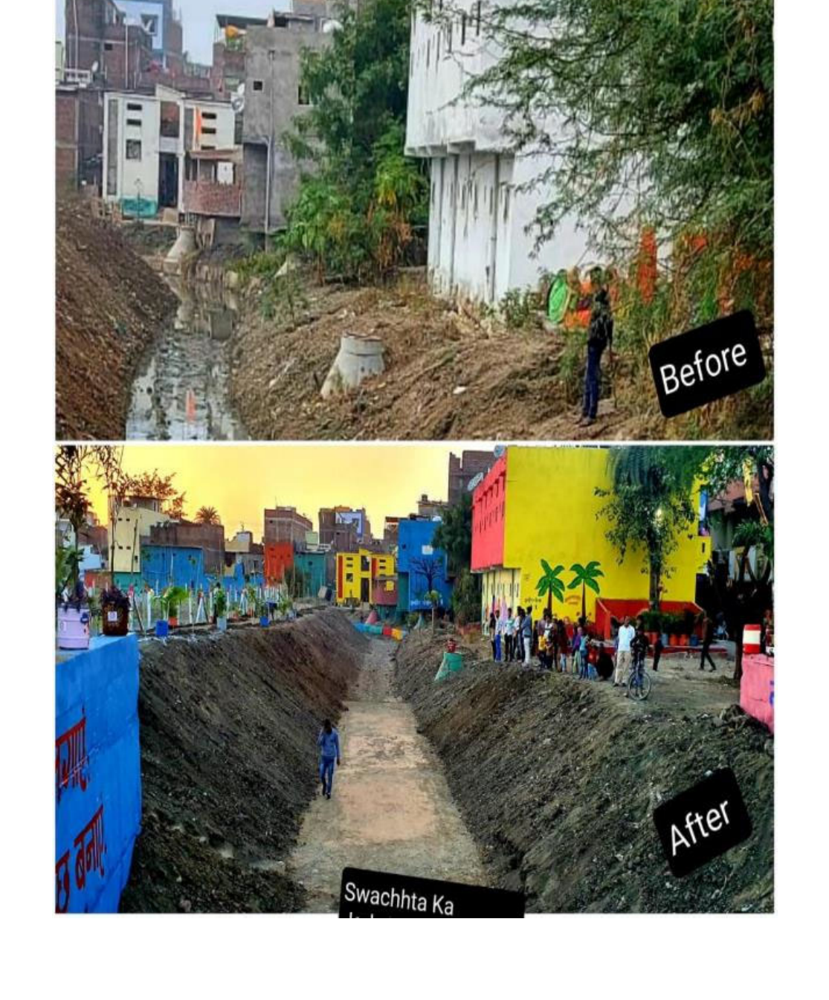 | 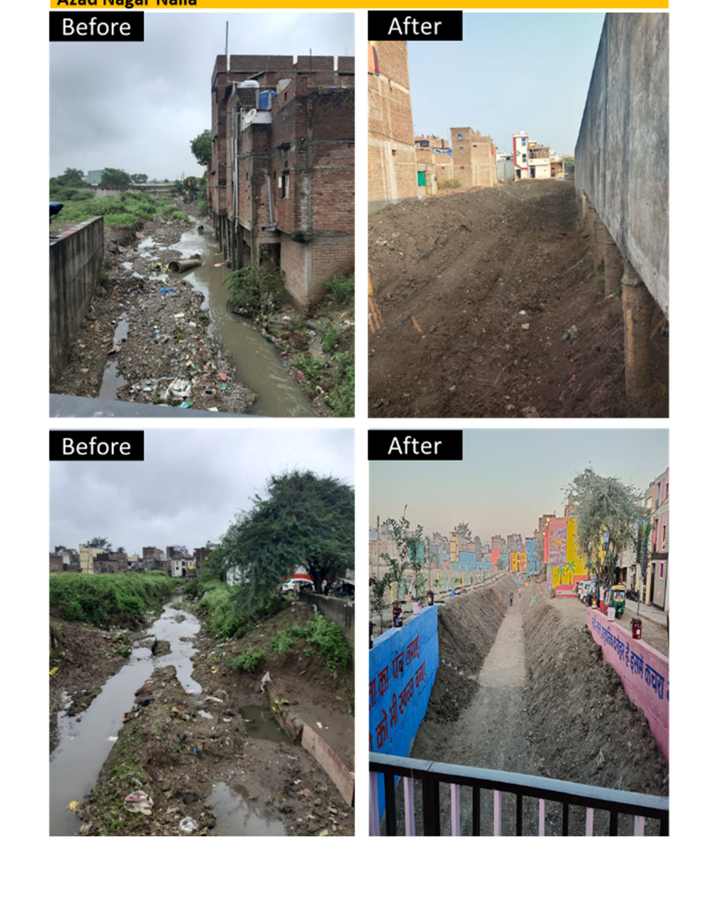

3. Project Understanding and Objectives

Objectives
1. Baseline Status Assessment
To conduct an independent, division-wise baseline assessment of the drain cleaning status across all identified stretches, establishing the actual on-ground condition prior to the monsoon deadline.
2. Deficiency Identification & Documentation
To identify drains that are not cleaned, partially cleaned, or clogged, and prepare structured deficiency reports categorized contractor-wise and division-wise for focused corrective action.
3. Compliance Verification
To assess adherence to the prescribed scope of work, including full-depth desilting, obstruction removal, proper silt disposal at designated locations, and restoration of hydraulic flow capacity.
4. Re-Verification After Corrective Action
To conduct a second-phase inspection of all drains identified as deficient during the baseline assessment and verify satisfactory completion of corrective cleaning.

5. Monsoon Readiness Confirmation
To confirm that the drainage network is fully cleaned and functionally ready before 15 May, minimizing the risk of water-logging during the monsoon.
6. Monitoring & Decision Support
To provide management dashboards and structured reports that support timely decision-making, enhance contractor accountability, and enable effective progress tracking.

4. Scope of Work

Overall scope
QCI will conduct a two-phase verification programme covering all divisions and contractors involved in drain desilting/cleaning.

Phase | Purpose | Outputs
Phase 1: Baseline assessment | Division-wise inspection to identify drains that are not cleaned, partially cleaned or clogged. | • Contractor-wise and division-wise deficiency list  • Baseline scorecards and dashboard  • Priority list of critical/failed stretches
Phase 2: Re-verification | Re-inspection of drains identified as deficient in Phase 1 to confirm corrective cleaning. | • Closure verification report  • Updated dashboard  • Report confirming cleaning before 15 May

What will be verified
- Physical condition of drains: silt removal, free flow, removal of solid waste and blockages
- Compliance with scope elements such as cleaning of bell mouths/kerb channels and maintenance of manholes/drain covers (as applicable)
- Evidence and documentation submitted by contractors (geo-tagged photos/videos, dumping receipts, daily progress data)
- Safety and traffic management practices followed during desilting operations (spot checks)
Exclusions (for clarity)
- QCI will not perform desilting/cleaning work; QCI will only verify and report
- Repair/rehabilitation works beyond cleaning (civil works) are outside this scope unless specifically included by the client
- Enforcement actions against contractors will be undertaken by the competent authority; QCI will provide evidence and recommendations

In scope – what QCI will do | Out of scope – for clarity
• Plan and execute division-wise inspections (Phase 1 baseline + Phase 2 re-verification)  • Classify drains as Cleaned / Partially cleaned / Not cleaned / Clogged (with evidence)  • Prepare contractor-wise and division-wise deficiency lists  • Share weekly dashboards, escalation notes and closure tracking  • Issue final certification report before 15 May (as per agreed criteria) | • Actual desilting/cleaning work execution  • Civil repairs/rehabilitation works beyond cleaning unless assigned separately  • Enforcement / penalty actions against contractors (to be done by competent authority)  • Any statutory approvals, road closures or traffic permissions

5. Methodology and Approach

5.1 Verification framework
QCI will use a structured verification framework combining (a) 100% desk review of contractor submissions and progress data, and (b) targeted on-ground inspections. This approach enables large network coverage while ensuring high confidence through physical validation and re-verification of failures.
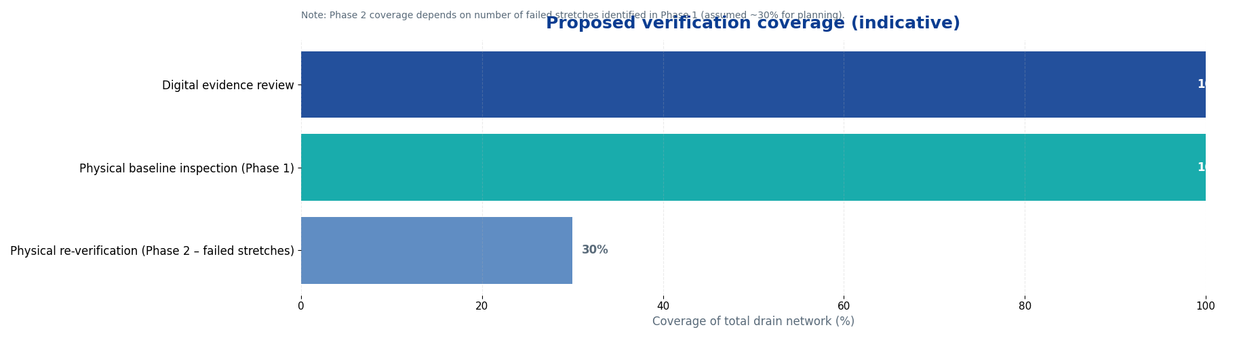
Figure: Proposed verification coverage (indicative; Phase 2 depends on failed stretches identified in Phase 1).
5.2 Data sources and evidence review
- Awarded scope of work and work orders (WO) issued to contractors
- Division-wise drain inventory / drain list and work break-up
- Daily/weekly progress reporting formats provided by the department (including drain length and silt quantity tracking)
- Geo-tagged photographs and videos submitted by contractors as part of documentation
- Disposal receipts from authorised dumping grounds, as applicable
Example: central dashboard inputs (from daily progress template)
QCI will consolidate division-wise progress and key metrics into a central dashboard. The chart below is an example of how division lengths can be visualised to plan inspections and prioritise risk.
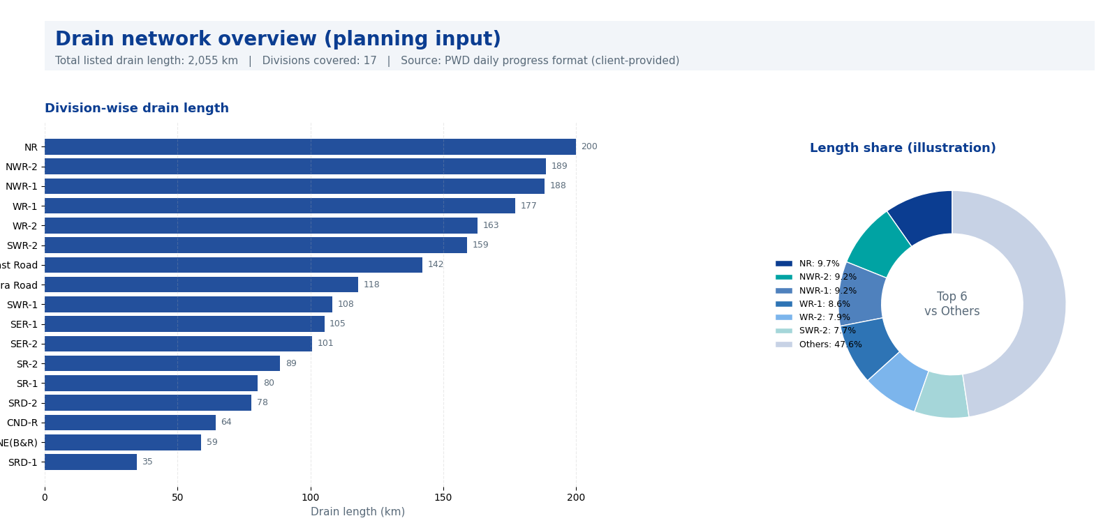
Figure: Drain network overview (division-wise length) – planning input from PWD daily progress format.
5.3 Field inspection design (full baseline coverage)
Given the high importance of preventing choked drains before the rainy season, QCI proposes a full baseline inspection of the drain inventory, supported by evidence review and priority routing:
- Phase 1: 100% baseline physical inspection of the drain inventory (division-wise), with geo-tagged photographs and standard checklist scoring
- Priority routing to complete high-risk locations early (underpasses, low-lying areas, chronic water-logging points, critical outfalls, and locations flagged by PWD)
- Phase 2: 100% re-inspection of all stretches marked as Not cleaned / Partially cleaned / Clogged in Phase 1 (closure verification)
- Surprise checks and data integrity validations (geo-tag/time-stamp checks, spot validation of locations, and cross-check with daily progress submissions)
5.4 Inspection checklist and scoring
Each inspected drain stretch will be assessed against a standard checklist. Key checks will include:
- Silt removal: drain bed visible and desilted to the bottom (as applicable)
- Flow condition: free flow without stagnant water due to blockage (subject to site conditions)
- Solid waste removal: plastics, building debris and floating waste removed
- Inlet/outlet condition: bell mouths, kerb channels and catch pits are cleaned and numbered (where applicable)
- Disposal compliance: evidence of transport and disposal to authorised dumping ground (where applicable)
- Safety: barricading, warning signage, PPE for workers and traffic management during work
Sample scoring matrix (used for contractor/division scorecards)
Parameter | Score (0-5) | Evidence required | Comments / typical gaps
Silt removal & depth achieved | 0-5 | Photo/video, on-ground check | Silt left at bottom; partial desilting
Free flow & choking removed | 0-5 | On-ground check | Localized blockages; stagnant water
Solid waste removed | 0-5 | Photo/video | Floating waste, plastics, C&D waste
Bell mouths / inlets cleaned | 0-5 | Photo, checklist | Inlets clogged, numbering missing
Disposal compliance | 0-5 | Dumping receipts, vehicle photos | Receipts missing / delayed submission

5.5 Quality assurance and data integrity
To ensure robustness, transparency, and fairness in assessment, QCI will implement a structured multi-layer quality assurance framework:
- Standard Operating Procedures (SOPs) and structured training for all field assessors to ensure uniform interpretation of indicators and consistency in inspection methodology.
- Mandatory geo-tagging and time-stamping of all field evidence, along with random reverse validation of submitted photographs and videos.
- Real-time quality audit of data collected by on-field assessors, wherein the in-house review team will verify submissions location-wise on the same day to check completeness, accuracy, and compliance with protocols.
- Supervisory audits by the Associate Manager on a defined sample of inspected sites for secondary verification and credibility assurance.
- Daily centralized review of collected data to identify anomalies, inconsistencies, missing evidence, or abnormal scoring patterns before finalization.
This multi-tier mechanism ensures that each inspected location undergoes both field-level and centralized scrutiny before acceptance.
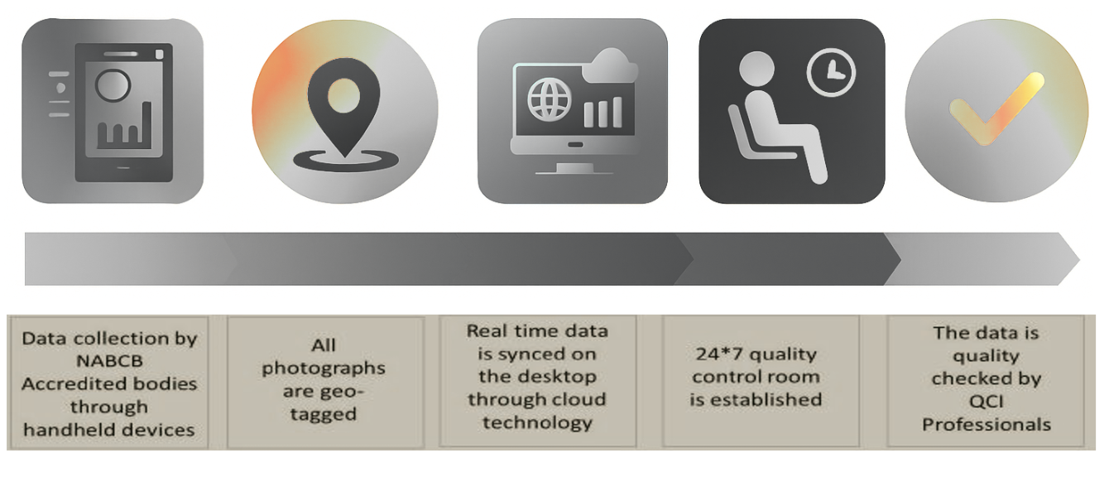

6. Deliverables and Reporting

Deliverables
- Inception note: final protocol, sampling plan, templates, and reporting calendar
- Phase 1 baseline report: status classification (cleaned/partially cleaned/not cleaned/clogged) and deficiency list (division-wise and contractor-wise)
- Interactive dashboard (Excel/Power BI-ready): progress, failures, closure status, photographs index, and priority list
- Phase 2 re-verification report: closure verification for all failed/uncleaned drains from Phase 1
- Final certification note (before 15 May): confirmation of readiness based on verification evidence
Reporting cadence
Report / output | Frequency | Audience
Daily dashboard refresh (internal) | Daily during fieldwork | QCI + nominated PWD focal points
Phase 1 interim deficiency list | Weekly during Phase 1 | PWD division teams + contractor coordination
Phase 2 closure tracking | Weekly during Phase 2 | PWD leadership + divisional engineers

Contractual requirements to be checked (as applicable)
Examples of checks that will be included in QCI verification:
- Geo-tagged photos and videos for drain stretches, as per agreed documentation protocol
- Evidence of waste/silt disposal to authorised dumping grounds, along with receipts
- Timely removal of desilted material from site to prevent it from falling back into the drain
- Safety measures: barricading, warning signage, traffic marshals (where required), PPE for workers
- Identification and escalation of water-logging/overflow risk due to inadequate desilting

Illustration: Monitoring dashboard (sample view)

QCI will provide a simple, decision-friendly dashboard to help PWD track division-wise status, contractor-wise deficiencies, and closure before 15 May. The view below is illustrative.

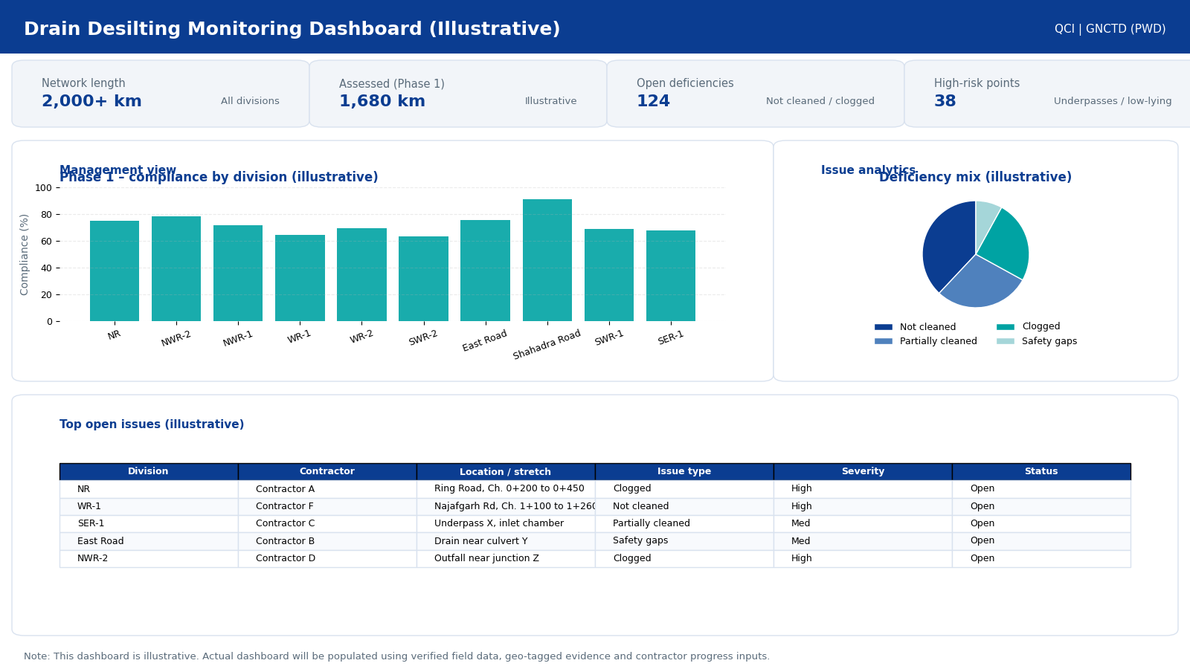

Figure: Illustrative dashboard mock-up (actual dashboard will be populated using verified data).

7. Governance and Communication

A clear governance mechanism will be followed to ensure timely action and quick closure of deficiencies.
Proposed governance structure
- Client Nodal Officer (PWD): single point for approvals, access, and escalation
- Weekly review meeting: progress, key risks, contractor performance highlights, closure plan
- Division coordination: QCI coordinator will align daily with divisional teams for site access and location confirmation
- Issue escalation: high-risk chokepoints or repeated failures will be escalated within 24 hours

Communication protocol
QCI will share deficiency lists and evidence in a structured format. Contractors will be given a clear opportunity to take corrective action, and Phase 2 verification will confirm closure.

8. Timeline

The client intends to complete verification before the rainy season. The proposed plan below ensures Phase 2 re-verification and final certification before 15 May.
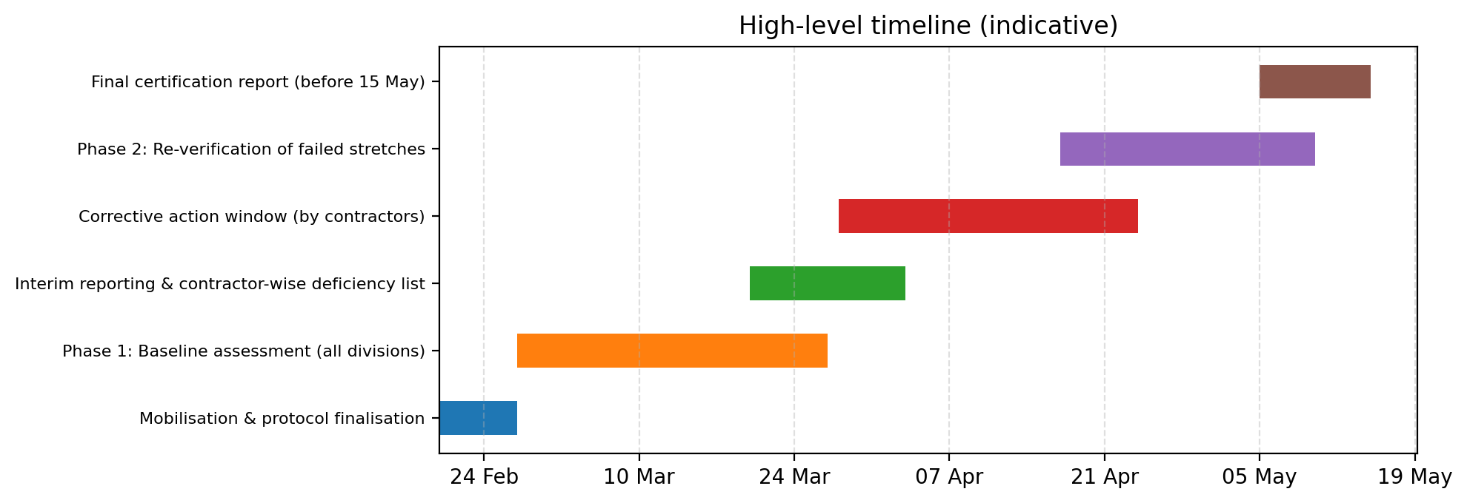
Figure: Indicative timeline (dates can be adjusted as per start date).
Key milestones
- Week 1: Kick-off, finalise protocol, agree division-wise plan and priority locations
- Week 2-5: Phase 1 baseline assessment and weekly deficiency reporting
- Week 6-9: Corrective cleaning by contractors; Phase 2 re-verification of failed locations
- By 15 May: Final certification report and closure dashboard

9. Team and Deployment Plan

QCI will deploy a dedicated team with clear accountability for delivery, data integrity and reporting.
Team structure (indicative)
Role | Key responsibilities | Planned deployment
Project Manager | Overall leadership, client coordination, approvals, risk management, final sign-off | 3 months
Associate Manager | Field quality assurance, sampling supervision, audit checks, dashboard review | 3 months
Analyst | Data consolidation, dashboard preparation, evidence indexing, MIS reporting | 3 months
Coordinators (2) | Division coordination, site scheduling, daily tracker management | 3 months
Field Assessors (pool) | On-ground inspections (Phase 1 & Phase 2), geo-tagged photo capture, checklist scoring, issue tagging and closure verification | 8 teams (16 assessors)  ~33 working days  (~528 man-days)

Resource effort (indicative)
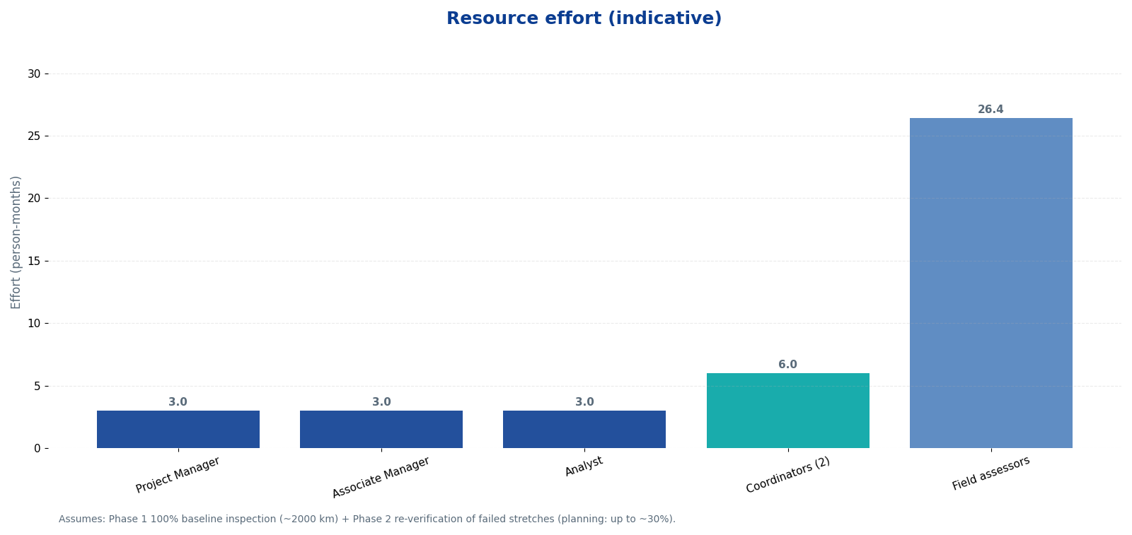
Figure: Estimated effort by role (person-months).

Deployment approach
- Assessors will be deployed in 8 parallel teams (16 assessors) across divisions to complete Phase 1 baseline inspection within the planned window
- Routes will be finalised daily based on priority locations and access confirmation
- Supervisory audits and surprise checks will be performed to ensure scoring consistency, safety compliance checks and data integrity
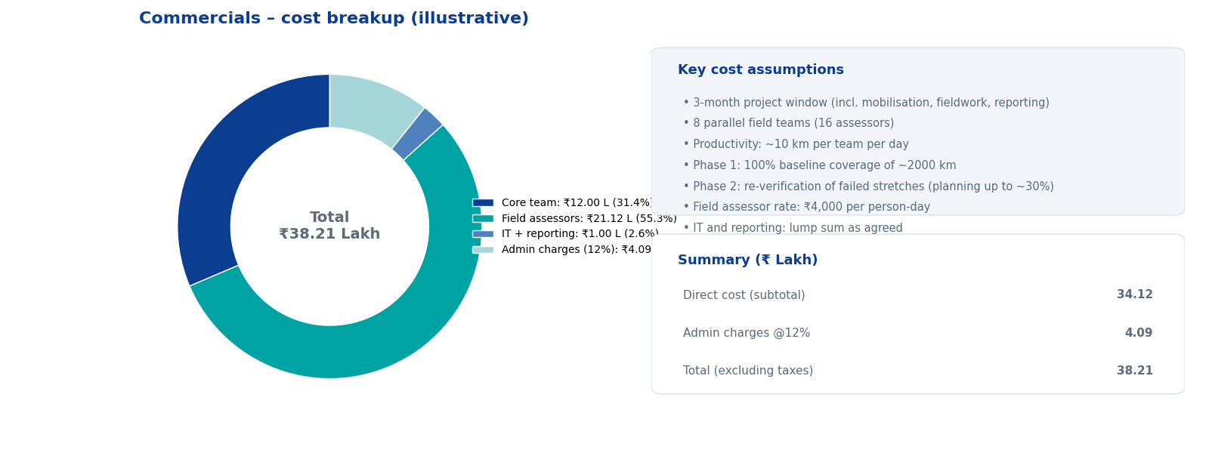

10. Assumptions, Dependencies and Risk Management

Assumptions
- PWD will share the latest division-wise drain inventory, contractor mapping and work orders/WO details at project start
- PWD/divisional teams will support access to drain locations and provide priority list of chronic water-logging points
- Contractors will provide required progress data and evidence (photos/videos/receipts) in agreed formats and timelines
- Any restrictions on site access (security/traffic) will be communicated in advance
Dependencies from client/contractors
- Nomination of client nodal officer and division focal points
- Sharing of daily progress reporting data and contractor contact list
- Timely corrective action by contractors based on Phase 1 deficiency list
Key risks and mitigations
Risk | Impact | Mitigation
Site access constraints / traffic restrictions | Delays in field verification | Daily route planning with divisional teams; flexible teams; early-morning inspections where feasible
Inconsistent evidence submitted by contractors | Gaps in desk verification | Standard templates; evidence validation checks; escalation for non-compliance
Short time window before 15 May | Risk to closure timelines | Parallel teams; early Phase 1 completion; rapid deficiency reporting to enable corrective action
Rain events before completion | Difficult field conditions | Priority on critical points; adjust sequencing; focus on blockage removal verification

11. Annexures (Templates)

Annexure A: Sample field inspection checklist
Checklist item | Observation (Yes/No/NA) | Evidence / remarks
Drain stretch ID / chainage captured
Drain bed desilted (bottom reached)
No visible choking/blockage
Inlets / bell mouths clear
Solid waste removed from drain
Silt/waste removed from site in time
Safety measures in place (barricading, signage, PPE)

Annexure B: Deficiency list format (contractor-wise and division-wise)
Division | Contractor | Drain ID / Location | Length (m) | Issue type | Evidence reference | Corrective action due date | Closure status
NR | Contractor X | Road ABC, Chainage 0+200 to 0+450 | 250 | Clogged / not cleaned | Photo_2026-03-10_XX | Within 7 days | Open

Annexure C: Illustrative photographic evidence
Examples of before/after imagery that help confirm cleaning outcomes:
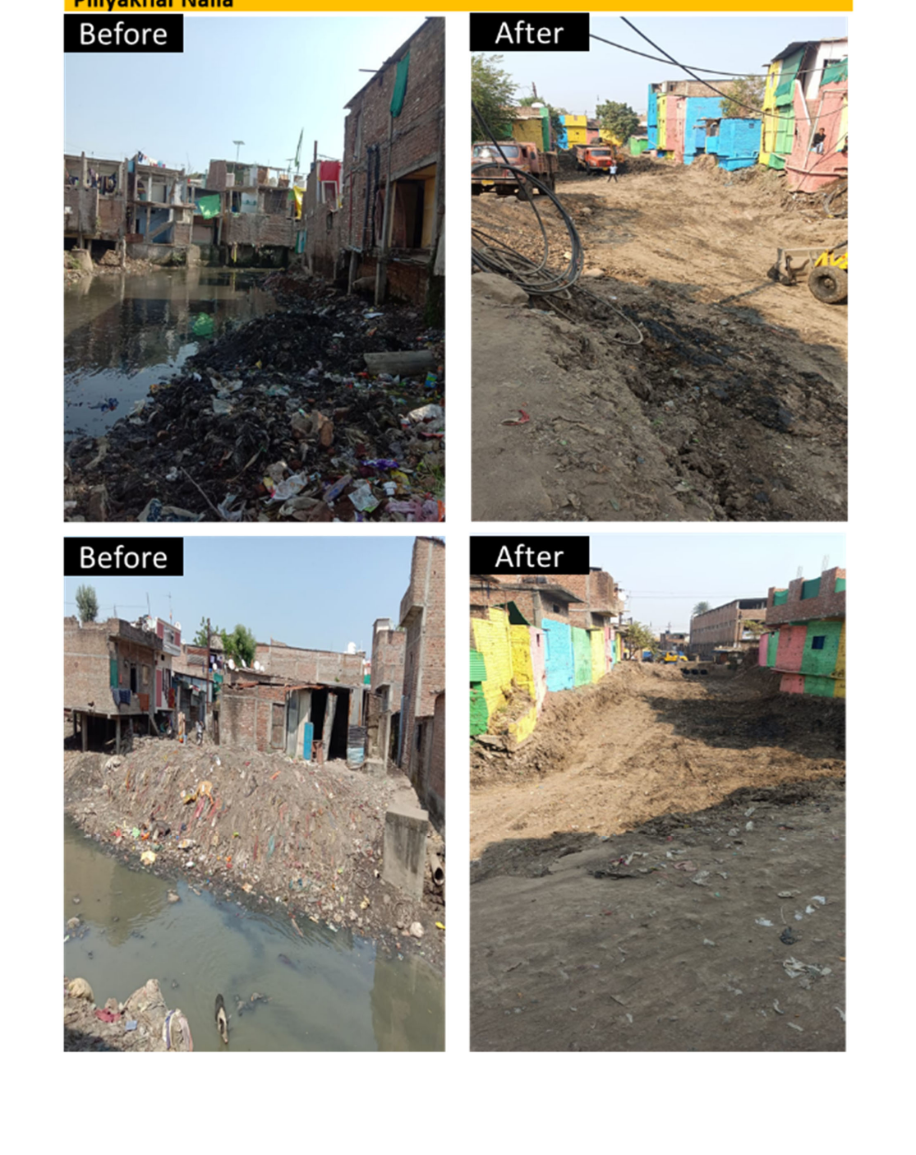
Annexure D: PWD daily progress proforma (key division fields – extract)
QCI will align its verification dashboard with the department’s daily progress format. The extract below shows key fields that will be used for division-wise monitoring and planning.
Name of Drain | Total drain length (km) | Desilted length (km) | Location not Desilted
S.P.M. Marg | 1.54
H. C. Sen Road | 0.15
Khari Baoli Road | 0.77
Esplanade Road | 0.20
Naya Bazar Road | 0.73
Zorawar Singh Marg | 0.59
Dewan Hall Road | 0.00
Lothian Road | 0.45
Sarai Phoose Road | 0.91
Hamilton Road | 1.69
N S Marg | 0.73
Jama Masjid Road | 0.37

Note: Values are taken from the client-provided daily progress workbook and are shown here only to demonstrate dashboard alignment.

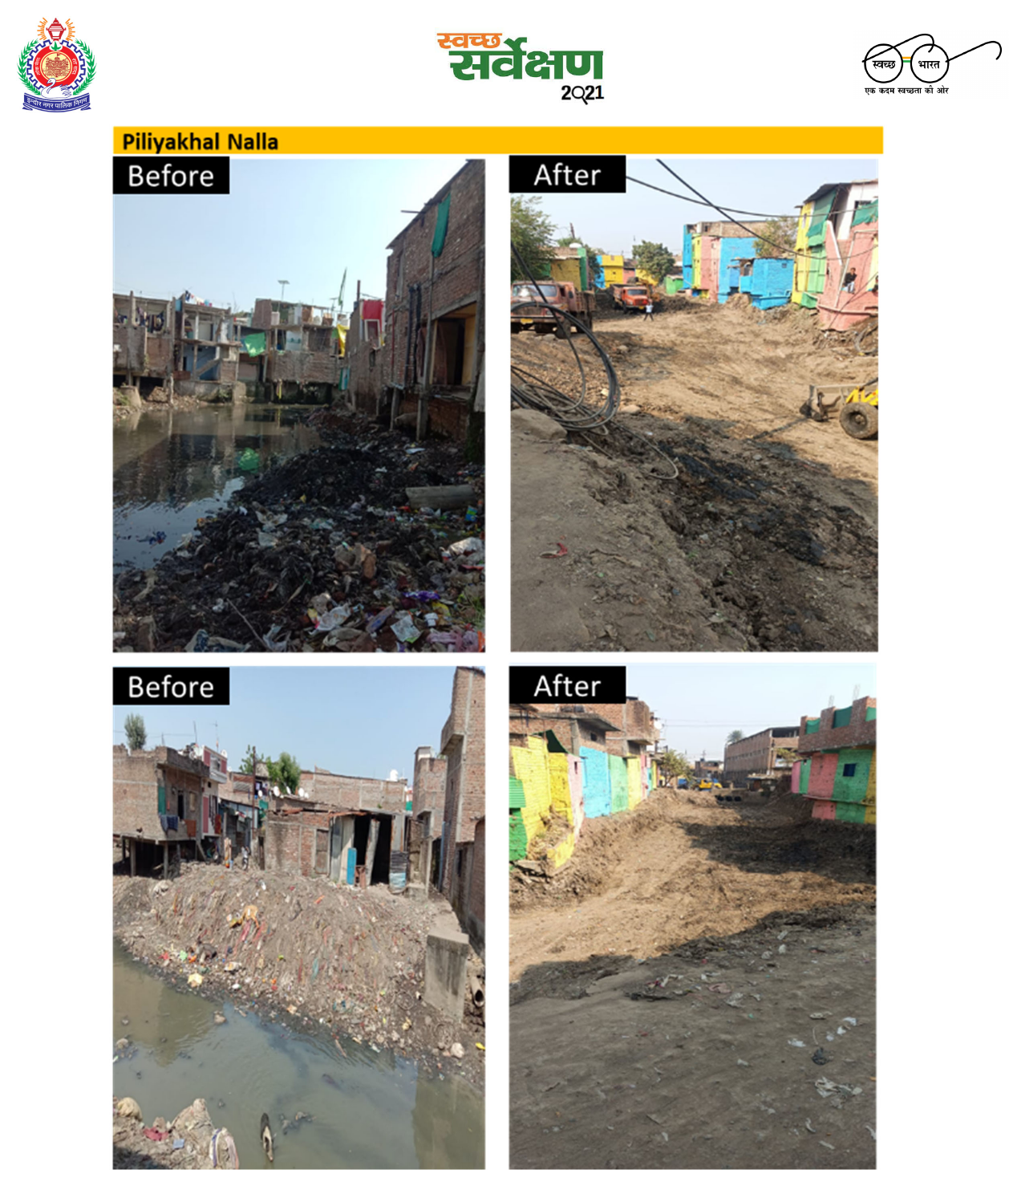Figure: Illustrative before/after images (from reference document provided).

Contact and next steps
Upon approval, QCI will nominate the project team and share the inception note within 3 working days.
Primary contact | Secondary contact
Project Manager (QCI)  Name: TBD  Email: TBD  Phone: TBD | Associate Manager (QCI)  Name: TBD  Email: TBD  Phone: TBD
Client Nodal Officer (PWD)  Name: TBD  Email: TBD  Phone: TBD | Division focal points (PWD)  As nominated by client

